Install CPP Compiler and IDE
Contents
Install CPP Compiler and IDE 1
Integrated Development Environment (IDE) 1
Install MinGW-x64 Compiler for Windows 1
Add the MinGW-x64 Compiler to Your Path 2
Check your MinGW installation 2
Clang C++ Compiler for Mac 3
Install Visual Studio Code 3
Tutorial 1: Hello World for C++ 4
Online C++ Compilers 7
Other IDE’s 7
Assignment Submission 7

Time required: 60 minutes

Integrated Development Environment (IDE)
A good IDE (Integrated Development Environment) can help you create good code and can speed up the software engineering process. There are many good IDE’s available. Visual Studio Code will be used for most class demonstrations.

Install MinGW-x64 Compiler for Windows
NOTE: Kali Linux and most distributions of Linux already have a C++ compiler installed.
We will install Mingw-w64, which is a 64-bit C++ compiler for Windows. If you have a Mac, there is already a C++ compiler built-in along with Xcode.
Video Walkthrough: Install MinGW-x64
- Go to http://www.winlibs.com
- Go down the page to Release versions.
- Choose UCRT runtime GCC with MCF threads. We want the one to the right, without LLVM/Clang. (The exact version number will change over time.)
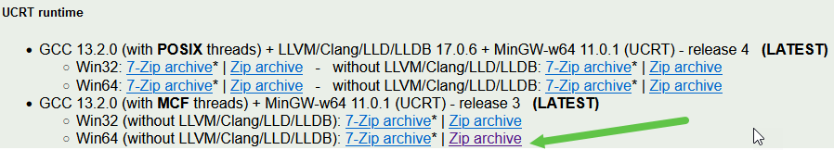
- Unzip the file you downloaded.
- Go into the extracted folder Keep going until you find the mingw64 folder.
- Copy this folder to your C: drive. C:\mingw64

Add the MinGW-x64 Compiler to Your Path
Add the path to your Mingw-w64 bin folder to the Windows PATH environment variable by using the following steps:
- Click the Start button Type in Environment Variables.
- Click Edit the system environment variables.
- In the System variables window Choose the Path variable select Edit.
- Select New add the Mingw-w64 destination folder path:
c:\mingw64\bin
- Select OK to save the updated Path.
- Restart your computer.

Check your MinGW installation
To check that your Mingw-w64 tools are correctly installed and available, open a new Command Prompt and type:
g++ --version
Example run:
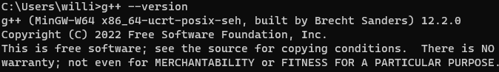
Your output should be similar, you may have a different version.
If you don't see the expected output or g++ is not a recognized command, make sure your PATH entry matches the Mingw-w64 binary location where the compiler tools are located.

Clang C++ Compiler for Mac
https://code.visualstudio.com/docs/cpp/config-clang-mac

Install Visual Studio Code
Microsoft Visual Studio Code is an opensource editor sponsored by Microsoft. Microsoft also owns GitHub.
Visual Studio Code integrates with GitHub Desktop. There is extensive information on how to get started with Visual Studio Code on the Visual Studio Code website.
- Go to https://code.visualstudio.com/download.
- Download and install the System Installer 64-bit version of Visual Studio Code for your operating system.
- During the installation: Select Additional Tasks, select the following items. You can create a desktop icon if you wish.
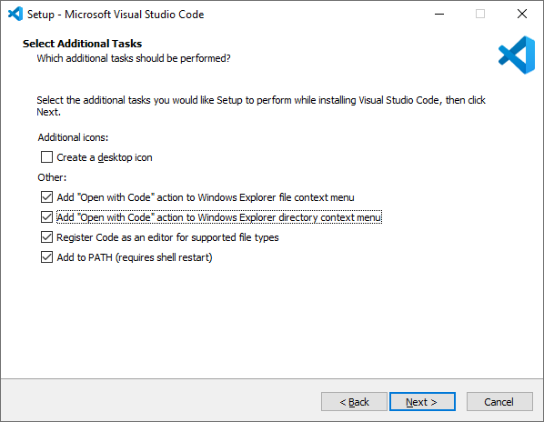
- Launch Visual Studio Code.
- Go to the View menu Extensions command.
- Search for C/C++ Extension Pack by Microsoft. Install it.

Tutorial 1: Hello World for C++
Hello World is the traditional program to determine if your development environment is ready to roll.
- Create a folder for your C++ code.
- Right Click the folder Choose Open with Code.
- In Visual Studio Code Right Click under the folder you created Name the file helloworld.cpp
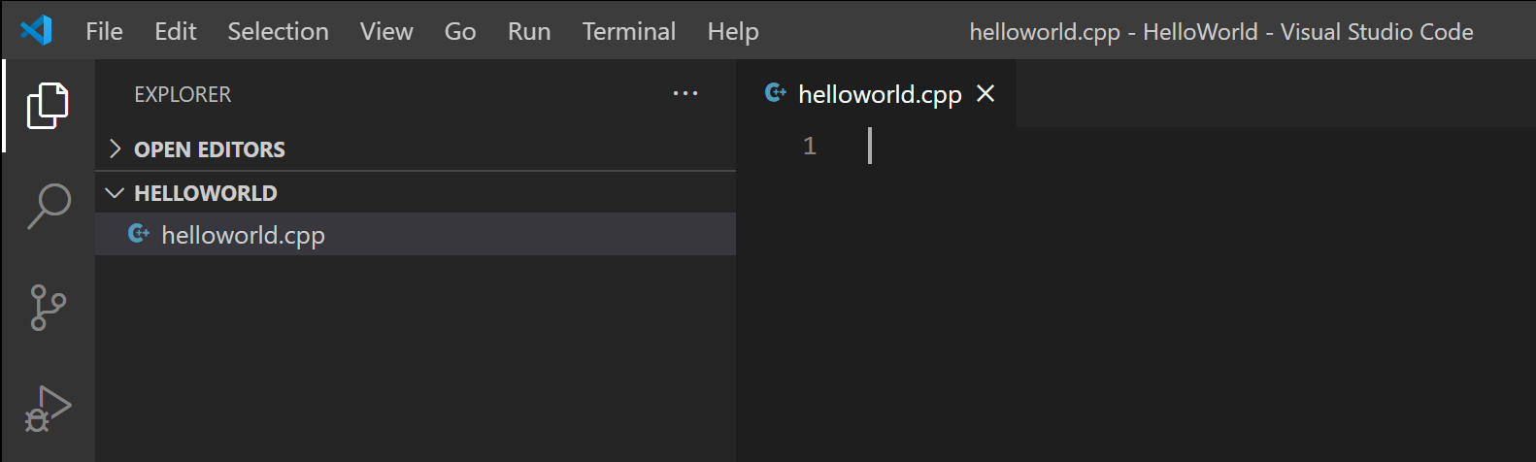
- Type in the following code exactly as shown.
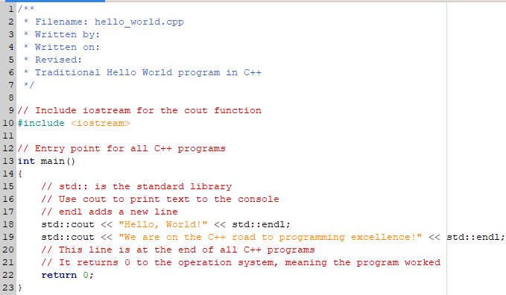
- Press CTRL + S to save the file.
- Build the program. Select the Terminal menu Run Build Task command (Ctrl+Shift+B).
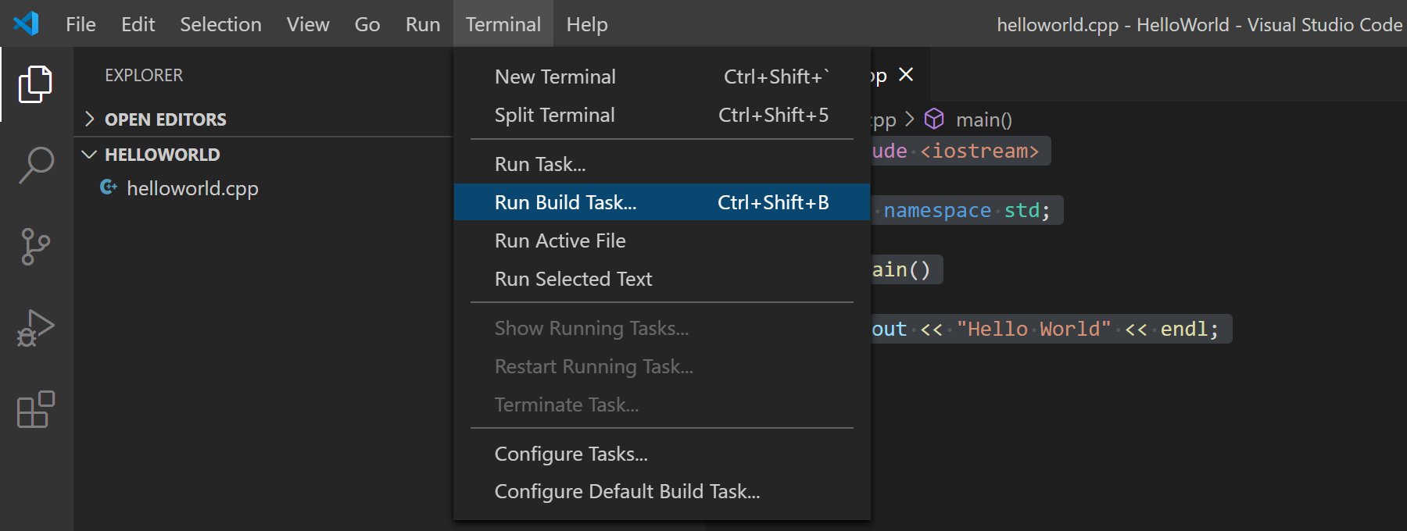
- This will display a dropdown with various compiler task options. You are using the GCC toolset MinGW, you would choose C/C++: g++.exe build active file
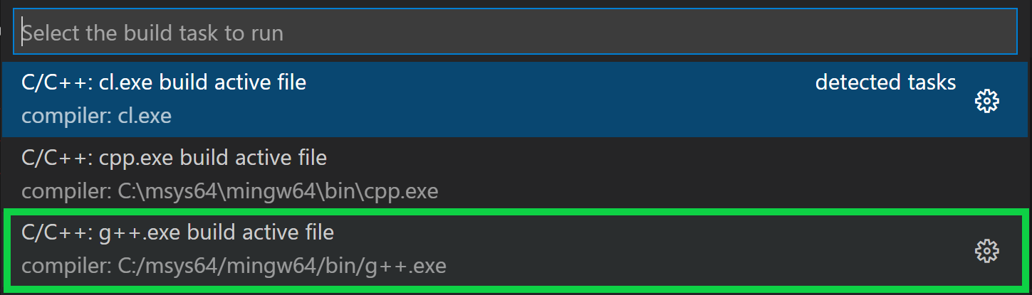
- This will compile helloworld.cpp and create an executable file called helloworld.exe which will appear in the File Explorer.
- Go to the Terminal menu New Terminal Type helloworld Press Enter.
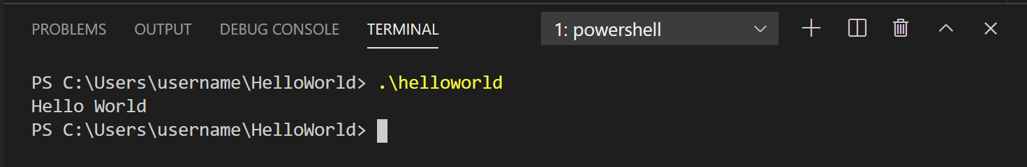
Tada! You compiled and executed your first C++ program!
Optional Tutorial: https://code.visualstudio.com/docs/cpp/config-mingw

Online C++ Compilers
- Replit
- https://wandbox.org/
- Compiler Explorer

Other IDE’s
At the beginning of your programming journey, it is a good idea to use a simple IDE like Geany or Visual Studio Code. You can concentrate more on the code than on learning the interface.
As you grow and gain more experience, you may want to experiment with more complex programming environments.
- Geany is a simple cross platform open source IDE for many languages. https://www.geany.org/
- Code Lite is a low overhead C++ IDE. https://codelite.org
- CodeBlocks is a C++ IDE that includes a compiler.
https://www.codeblocks.org/downloads/binaries

Assignment Submission
- Insert a screenshot showing a successful program run.
- Attach the .cpp file
- Submit in Blackboard.

